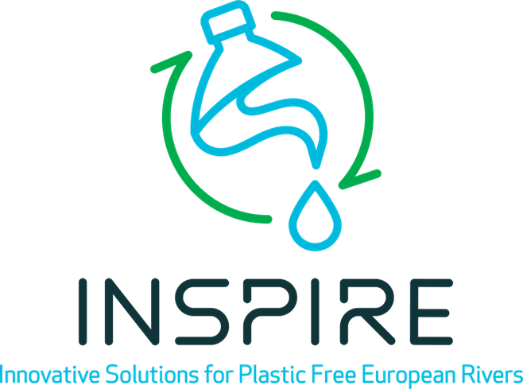

INSPIRE FSTP FAQ

- What type of organization is eligible for this application?
Local and regional authorities from an associated region, that are not based in INSPIRE partner countries. In all cases, the projects must be submitted by a local or regional authority (other type of entities might be subcontracted). In case of doubt, INSPIRE may request the applicant to provide a proof that the entity is a local or regional authority.

- Can I submit my application if my organization is not yet established?
No, you cannot. To be eligible, your organization should be legally established in one of the MS or associated countries mentioned in the Guide for Applicants, at the date you submit an application.

- Who can apply?
Eligible beneficiaries of this call are local and regional authorities from different European Member States, (including the EU Outermost Regions) or Horizon Europe associated countries (Association to Horizon Europe - European Commission). Please note that applicants from the following countries, where a project partner of INSPIRE is located, are ineligible for this call (i.e., Austria, Belgium, Croatia, France, Germany, Greece, Italy, Netherlands, Portugal, Romania, Serbia, Slovenia, Spain, and Sweden). UK is eligible for this FSTP.

Applicants must be eligible for participation in the EC Horizon Europe Framework Programme and must ensure the following obligations of the Grant Agreement, namely Articles 12 (conflict of interest), 13 (confidentiality and security), 14 (ethics), 17.2 (visibility), 18 (specific rules for carrying out action), 19 (information) and 20 (record-keeping).

- Can I apply together with other organizations?
Yes, but all applicants must be local and regional authorities to be eligible to receive the grant (other type of entities might be subcontracted).

- Where do I apply for the funding?
Applications to the open call must be submitted through the INSPIRE website: https://inspire-europe.org/open-call/. Applications submitted by any other means will not be considered for funding (will be rejected). We recommend using the application template and provide descriptions as guided.

- What happens if I do not submit my application within the deadline?
Applications submitted after the deadline (i.e. November 29, 2024, 17h00 Brussels time) a will be rejected. We strongly encourage you not to wait until the last minute to submit your proposal. Failure of meeting the submission deadline for any reason, including extenuating circumstances, will result in the rejection of the proposal.

- Can any legal entity submit two project ideas?
No, you cannot. In the case of more than one application being submitted from the same applicant, only the one submitted first will be considered and any others will be rejected.

- What costs are eligible?
The costs of personnel working under an employment contract with the beneficiary or an equivalent appointing act and assigned to the action:
{daily rate for the person multiplied by number of day-equivalents worked on the action (rounded up or down to the nearest half-day)}.

The daily rate must be calculated as: {annual personnel costs for the person divided by 215}
Subcontracting costs for the action (including related duties, taxes and charges, such as non-deductible or non-refundable value added tax (VAT)) are eligible.
Goods or services to carry out specialised tasks that beneficiaries cannot do themselves are eligible for supporting the main activities.
Purchase cost of equipment or other assets (new or second-hand) is eligible but will entail depreciation rules.
Indirect costs are costs are limited to a flat-rate of 15% of the total eligible direct costs for the action.

- What are the excellence criteria to assess the proposals?
The experts will evaluate the proposals by using the following excellence criteria:
The following sections of the proposal will have the same weight in the evaluation process. Each has a weight of 25% in the total evaluation
- CONCEPT AND INNOVATION: considers the project plan of the applicants to use the INSPIRE solutions in the respective replication areas.
- EXPERTISE AND EXCELLENCE OF THE PROPOSED TEAM: evaluation of the applicants’ purposes to use the INSPIRE solutions in the respective replication areas. The proposal(s) selected for funding must demonstrate a high quality.
- ALIGNMENT AND PROJECT PLANNING: consider the plans for interaction with the INSPIRE consortium, knowledge-sharing, and participation in the upscaling of the suggested methods and technology. The probability of successfully scaling up in the specified region will also take into account the applicants' discussion of local obstacles and proposed solutions for overcoming them.
- IMPACT AND SUSTAINABILITY: overall expected impact of upscaling of technology measures in the given region in the short and long term.

- What is the PITCH moment?
- Shortlisted applicants will be invited to the pitch presentation based on the evaluation of the submitted written proposals. The pitch will provide a chance to shape understanding of your project and we expect you to strategically highlight important contents. The pitch presentation will be maximum 10 minutes long, and will be followed by 10 minutes follow-up questions. Be prepared: You could consider pitching to your team
- Timing maters: Remember that the reviewers have already read your written proposal, so they are familiar with it from a high level. The pitch is a chance to shape their understanding of your project by strategically highlighting important content.

- What will I get if my application is selected?
You will receive 60,000-100,000 Euro to cover the costs of developing the roadmaps and strategies to scale up restoration actions in the replication sites (associated regions selected within this call). You will also receive technical mentorship and support from the INSPIRE consortium.
- 50 % of the total INSPIRE contribution at the start of the project
- 25 % of the total INSPIRE contribution after the evaluation of the first annual report, to be submitted at the end of the first 12 months of the project
- 25 % of the total INSPIRE contribution after 18 months, upon reaching the milestones set up to month 18 of the project

- What is a PIC number?
PIC stands for Participant Identification Code.
This code serves as a unique identifier of an organisation in the Commission's organisation register (Participant Register).

